Excel

Excel : workbook

Tabs:



Ribbon: options in tab

Name box and formula bar



Total area: sheet

By default 3 sheets

Cells

Cell is formed by row and column

Columns, rows and cells

Activated cell:

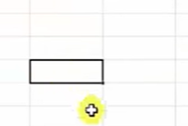

Columns: 65536

Rows:

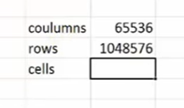

How to identify them?

Columns has labels: a,b,c,d,e,f

Rows: 1 t0

To go first column



To go to last column:







Cell address: columnrow(F10, F4)

Name box: can be used to know cell address

It can also be used to go to particular box

For that give address in namebox and click enter

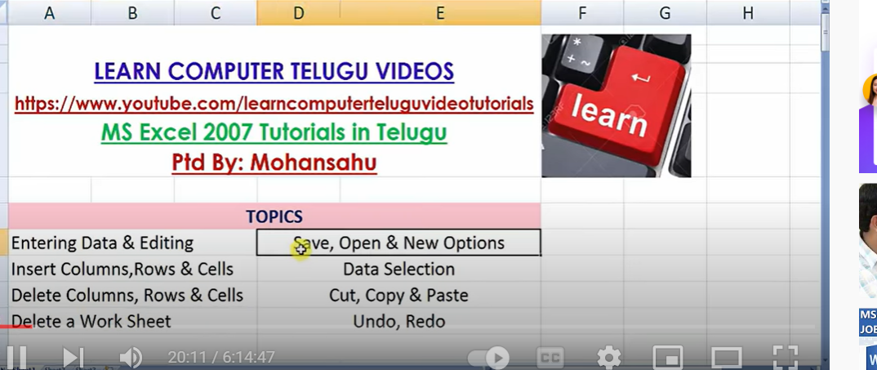

Serial Numbers:

Type 1st number

Write second number in second dow

Select both

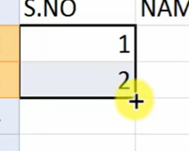

Keep curser at corner hold plus button and drag

Or give 1 number

Drag by holding Ctr button

Even and odd number: 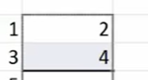

Difference bettwen numbers 5: 1,6 and drag

Even Sunday and drag

Or short cut name drag

Even months name

EDITING:

Edit specific cell

F2

Or

Double click on celll

Or formula button

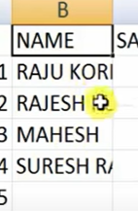

Name column or b column length is small, we need to increase

At Column alpha names

At row numbers

New column:

To enter column between name and salary

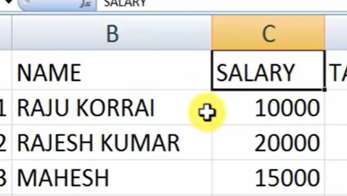

Keep c cell activated

Go to home button - cells group- insert- insert columns

For adding new row:

If I want to add a row above column names

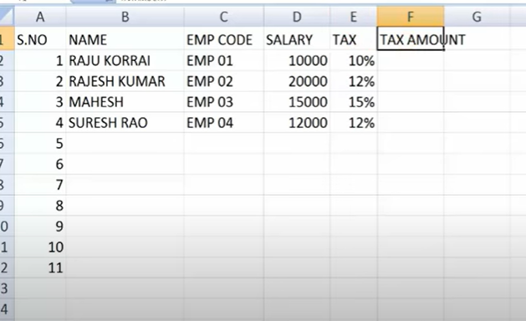

Keep any cell activated

Home- cell group- insert row

**Delete columns: cells : rows:**

**Delete columns:**

Whatever column which u wanted to delete – activate any cell in column- home-cell- delete – delete sheet columns

Delete row:

Same

Delete cells:

**Insert newssheet:**

Down +

F11

Or home – insert – insert sheet

Delete sheet :

NEW work book:

Cont N

To open files:

Control O

To save:

Control S

Save As:

F12

**Data selection:**

Column: to select total column

Just click on B column

Same to row

To select entire sheet

Control A

Or

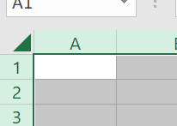

**To select required columns:**

Control and selected required columns

UNDO-REDO  


Undo cotrl Z

Redo Contr y

CUT<COPY <PASTE:

For to duplicate

Or moving from one sheet to others

Moving:

Select data , cut, control x and control v

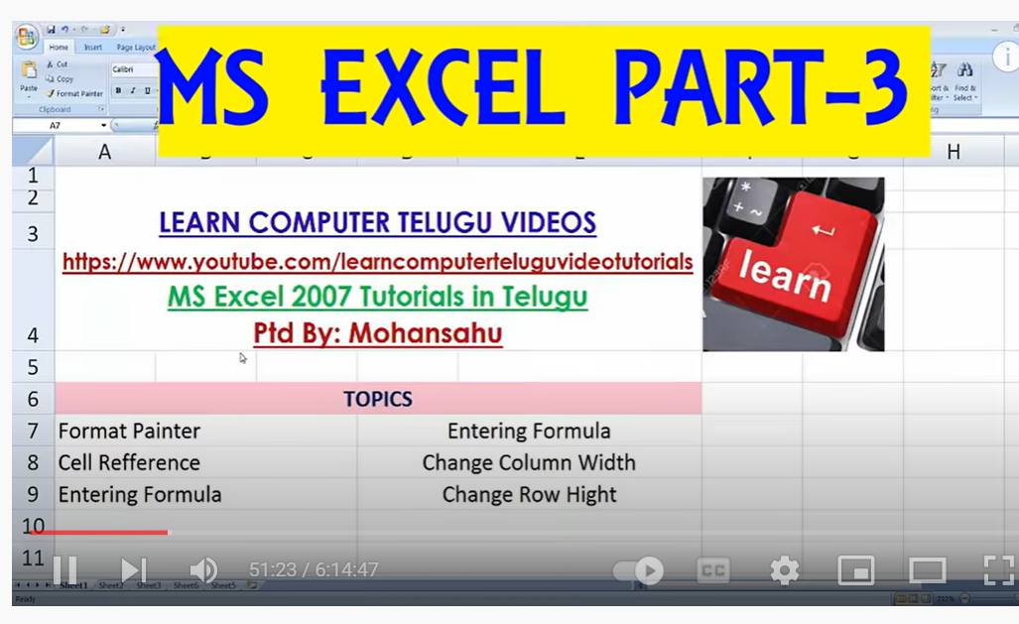

**Format Painter**

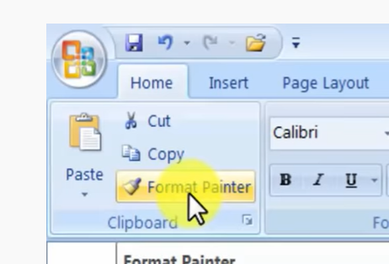

**When I want to select only format not content**

**Cell activate- select format painter – click on the cell which u want to apply**

**Pink box**

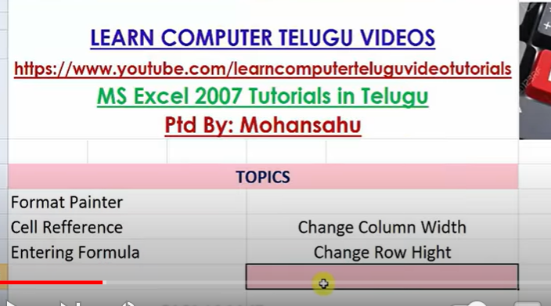

**CELL REFERENCE:**

**Cell address: C8**

**References are two types: relative reference and absolute reference**

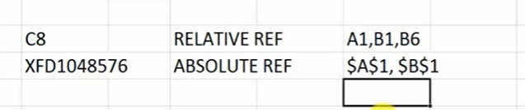

**When we calculate formula using relative reference can be spread to next cells**

**With absolute reference: we cant to other cells**

**How to create formula:**

**When we enter a value in a cell by placing = and enter value will be consider as formula**

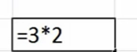

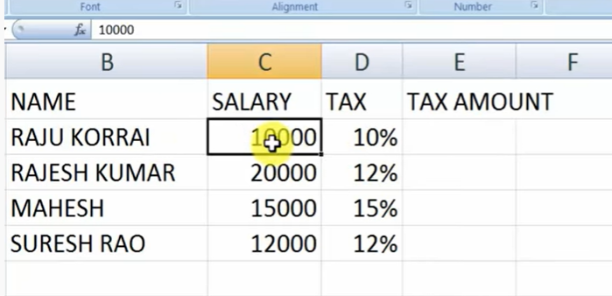

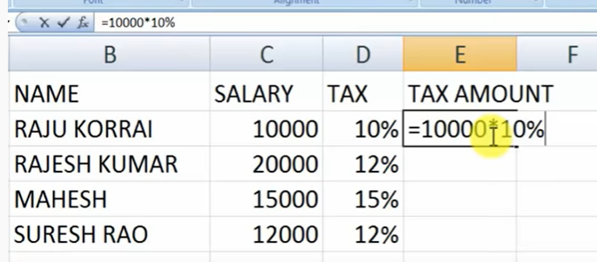

With this we cant apply to all other people

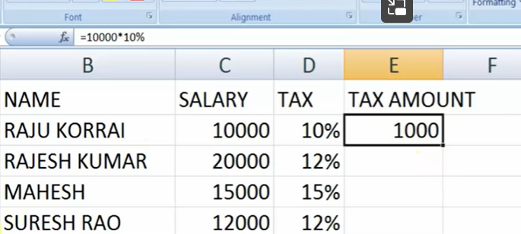

In order to apply to all cells

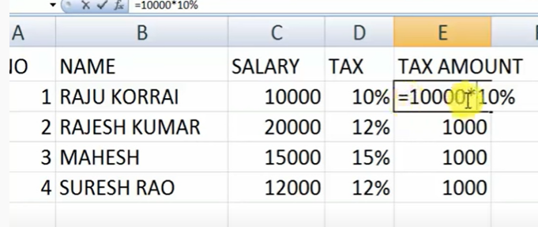

When we drag it same value to all cells

Instead of 1000 we must use cell address

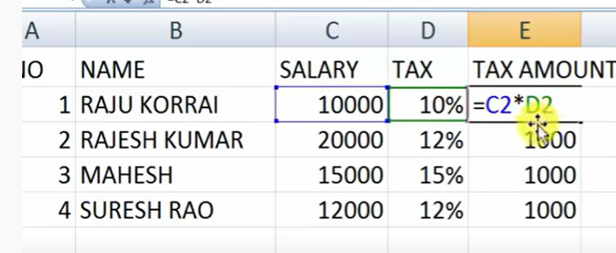

Now drag

Absolute reference :

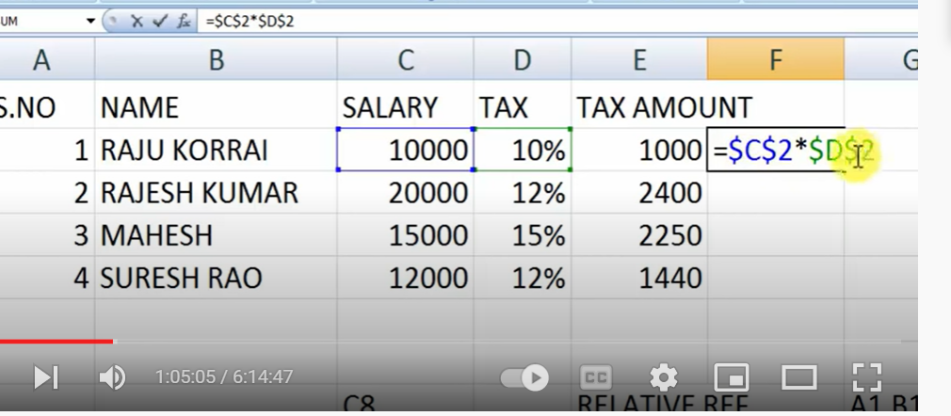

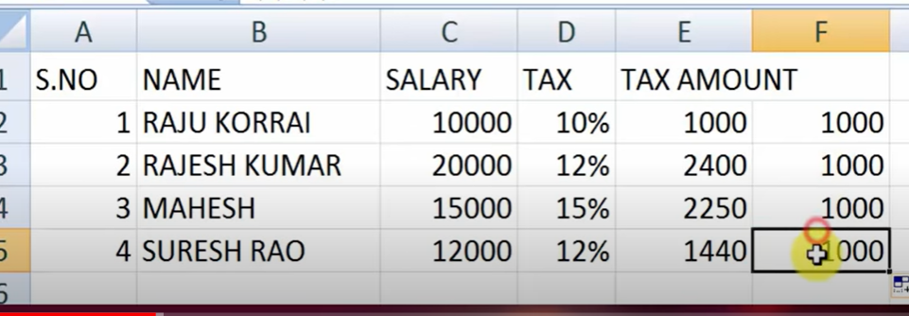

In absolute reference formula is not changing where as in relative reference formula is changing

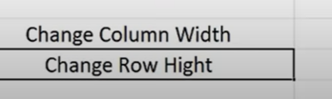

At a time when we want to change column width – select all columns – home-cell-format - 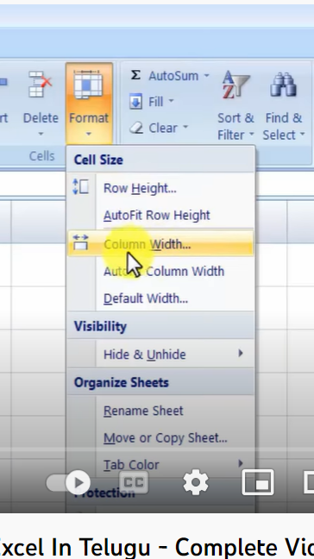

Widow will open – give dimensions

Rows- Row Hight

**HIDE and unHIde sheets**

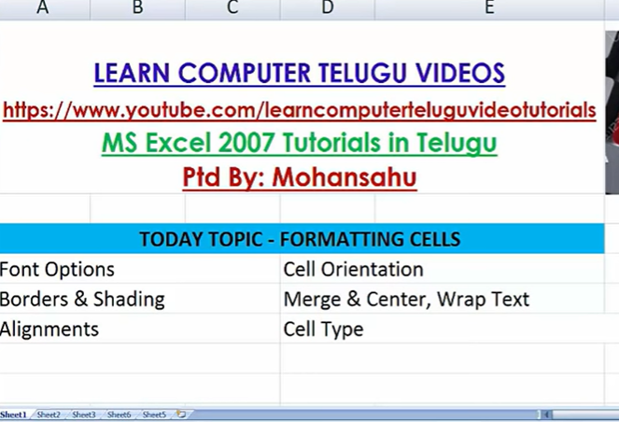

Extra formatting options:

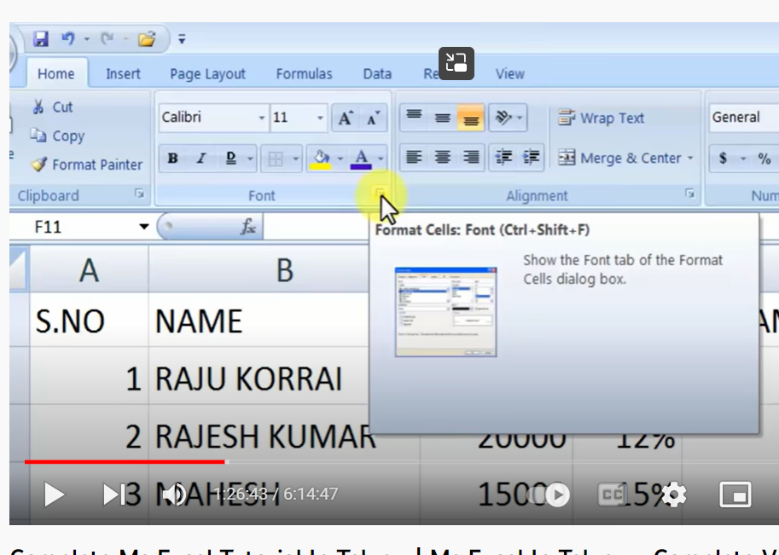

Group launcher

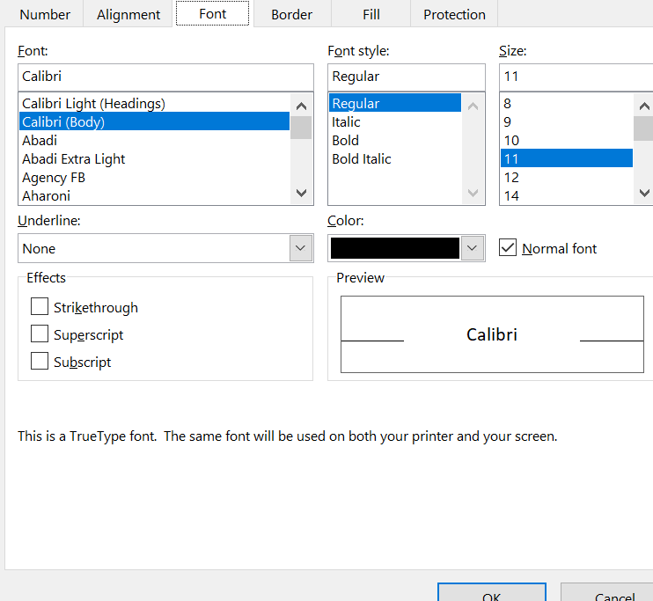

Auto fit row and column size: curser on a,b.. or 1,2 and double click

Giving separate title for each table

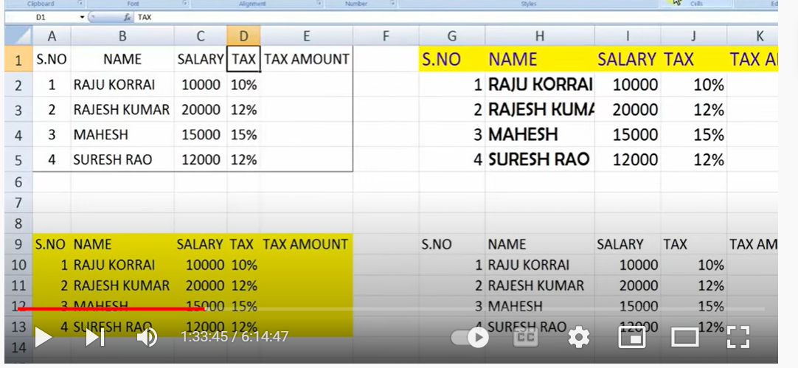

Select above columns

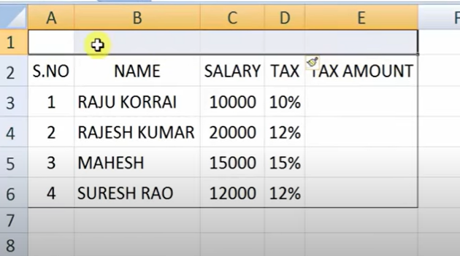

Select merge and center

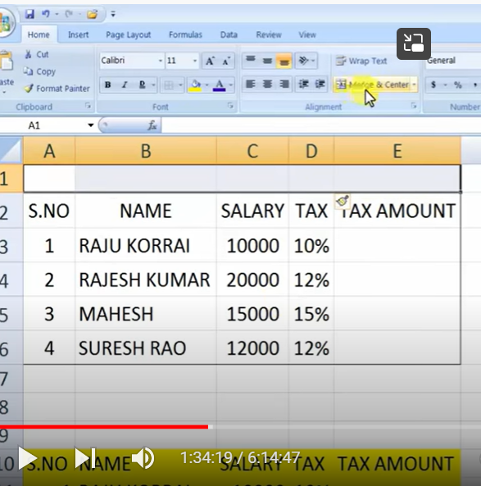

Give title

Unmerge option also will be there

**Wrapping Text**

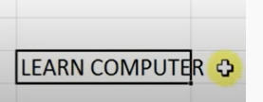

**When we press wrap text**



**CELL TYPE:**

**When we wanted to add on ly partial type of data in a column**

**Select that column – home**

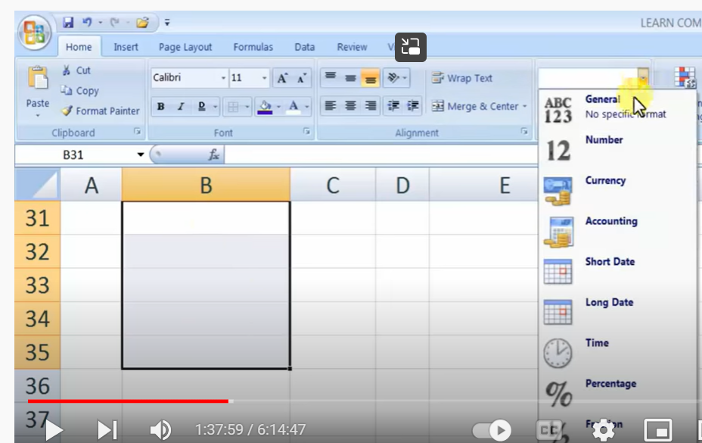

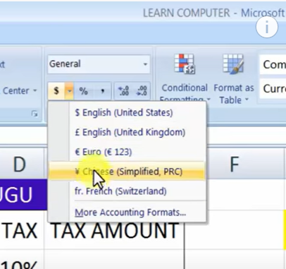

Decrease and increase decimals

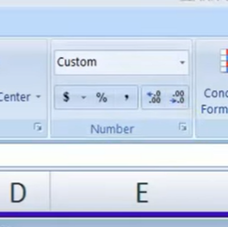

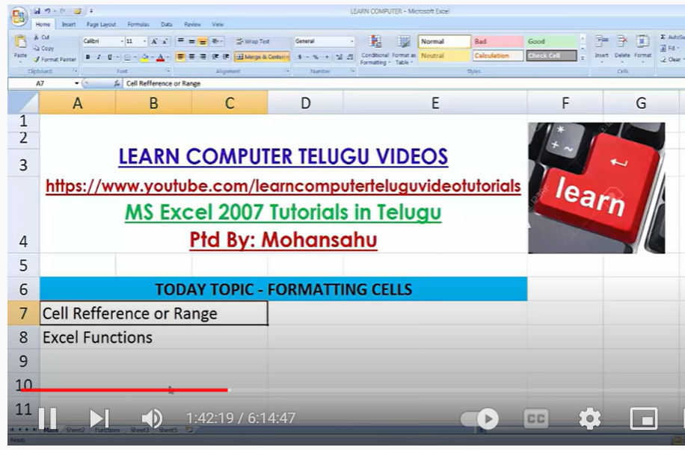

Group of cells- cell range or reference

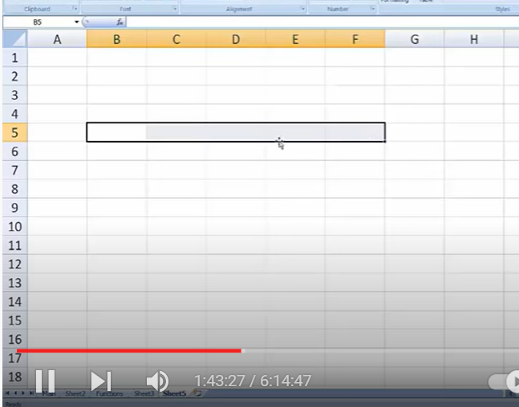

How to show

B5:f5

**Excel functions:**

**Own function**

**Predefined functions**

**Own :** 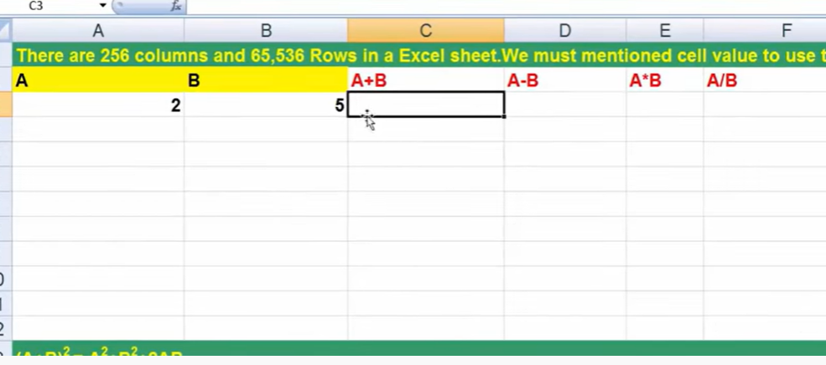

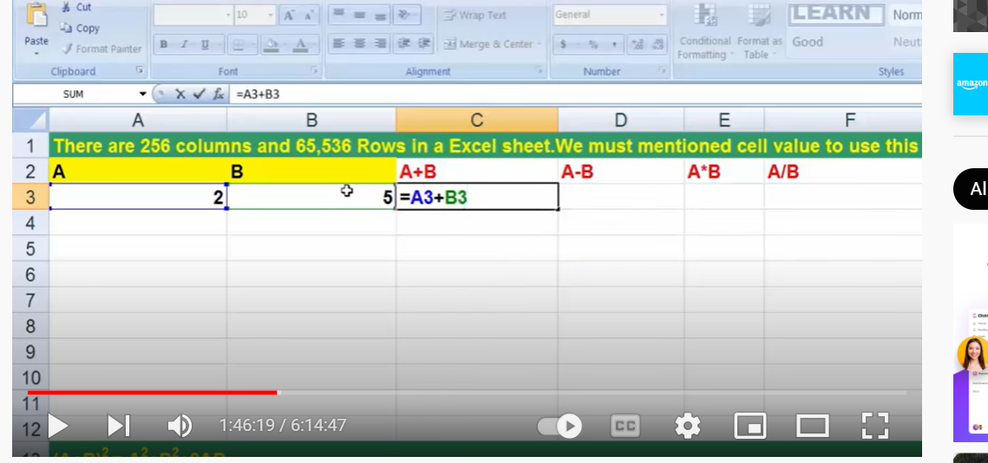

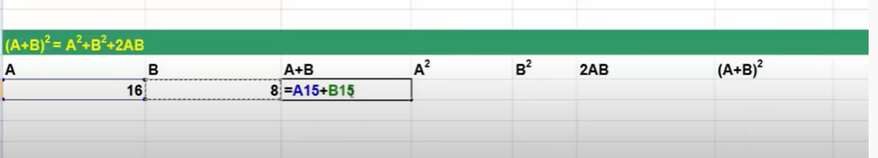

**Pre defined**

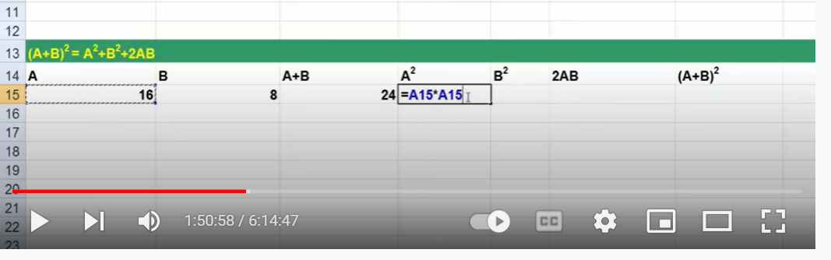

**Excel Functions:**

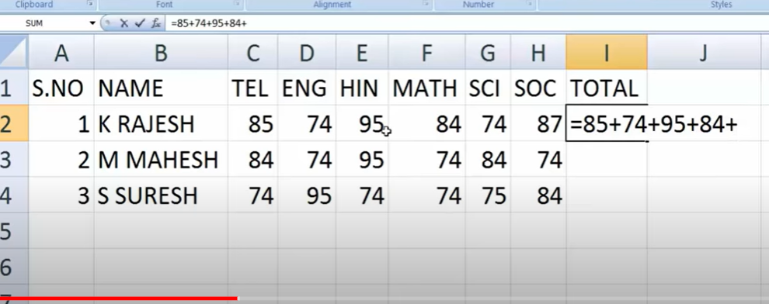

**Drag**

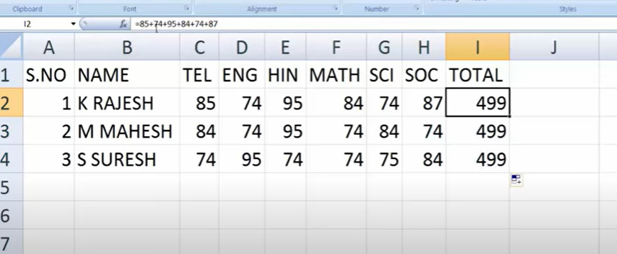

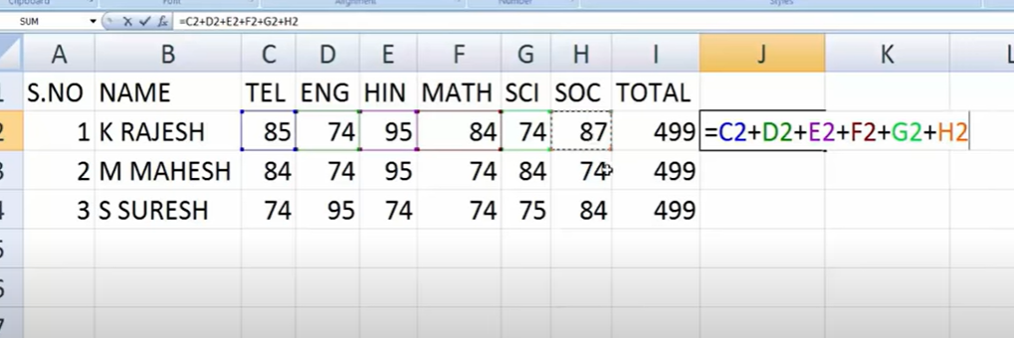

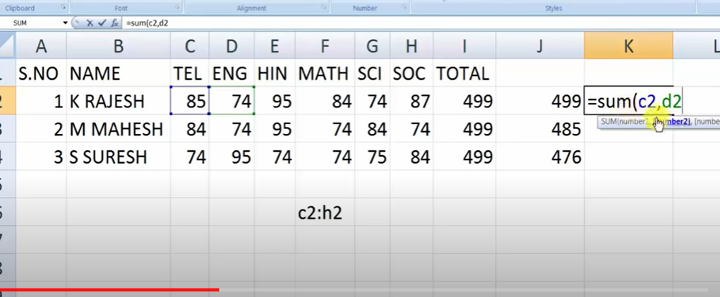

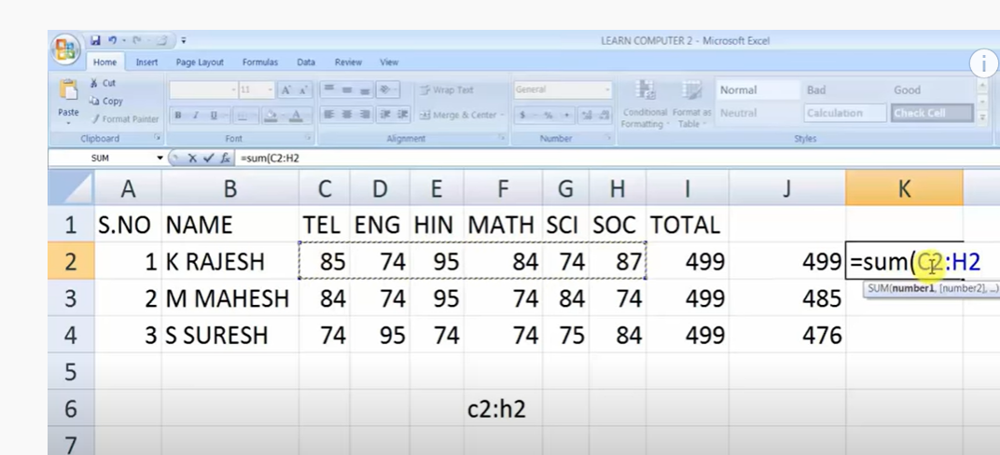

**Formulas**

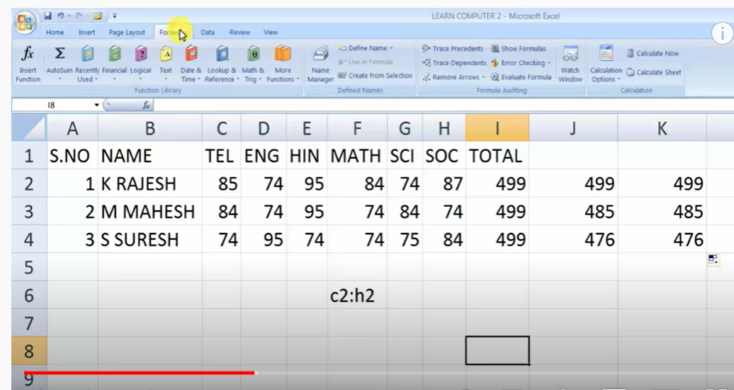

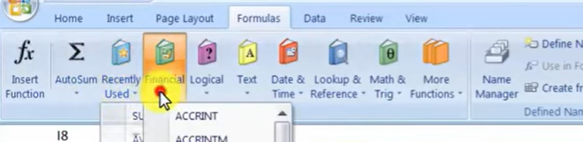

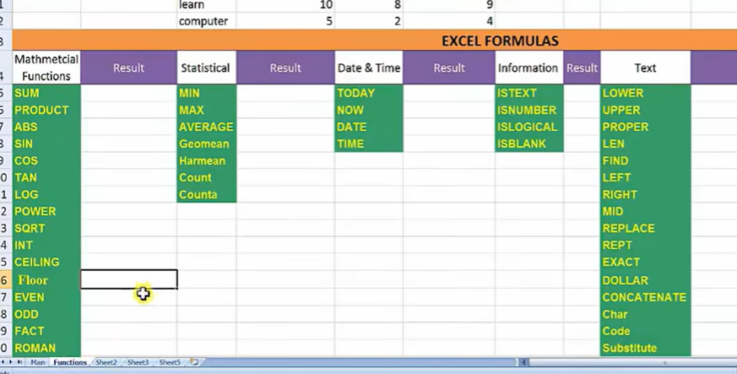

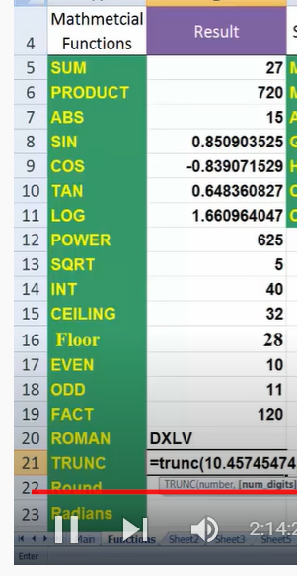

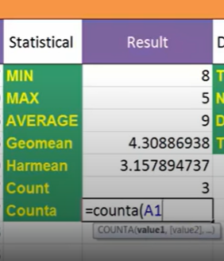

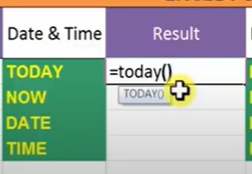

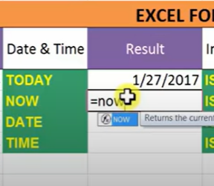

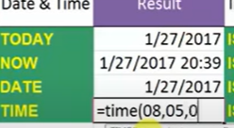

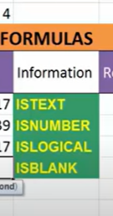

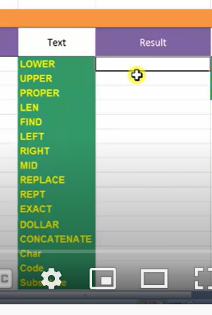

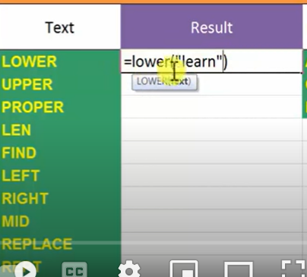

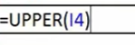

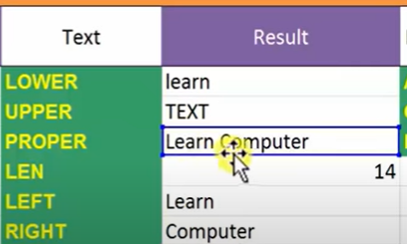

**How many characters in left**

**How many characters in right**

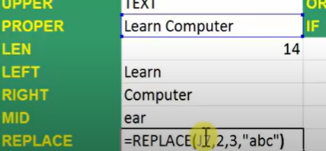

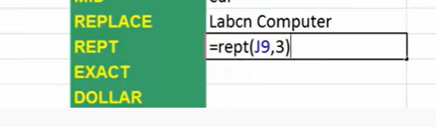

**Repition**

**To know if first and second text same**

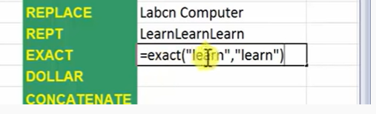

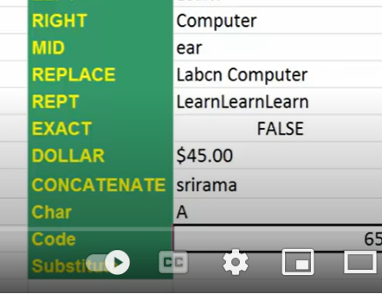

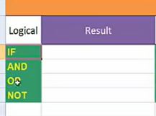

**Logical**

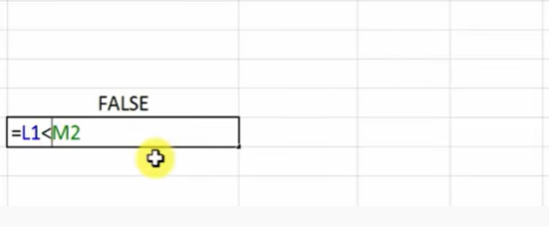

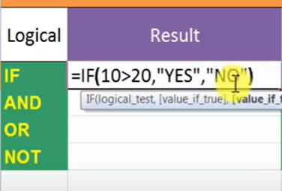

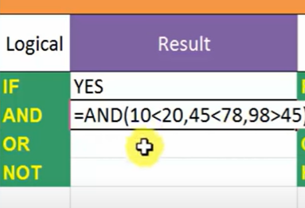

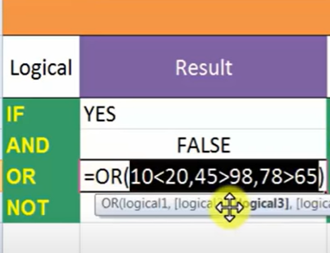

**Not is reverse**

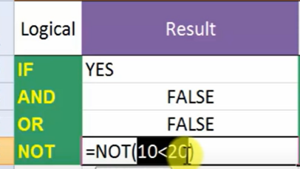

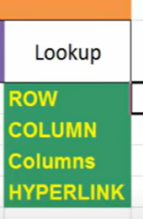

**Present which row**

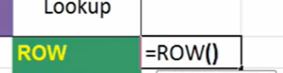

**Which column**

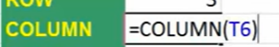

**Present column**

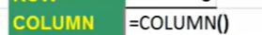

**How many columns**

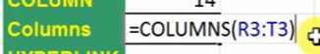

**How many rows**

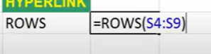

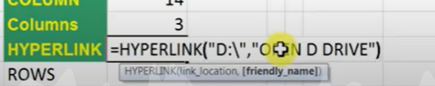



**Color styling**

**Cell style**

**Conditional formatting**

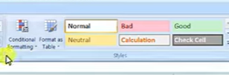

**cell style**

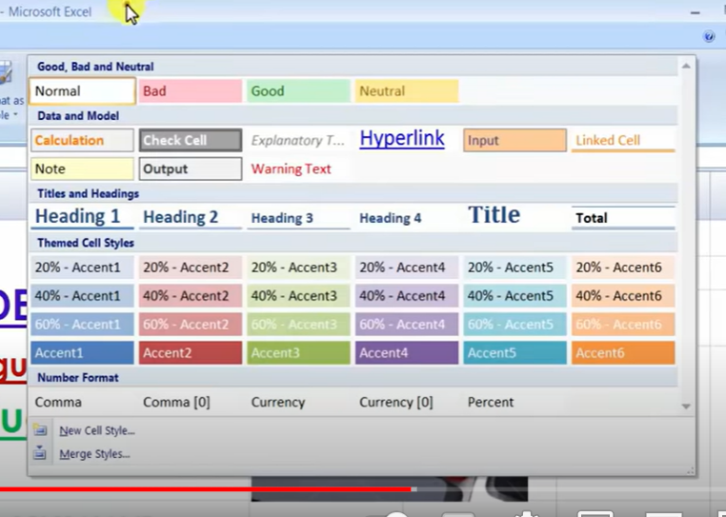

**Format as table**

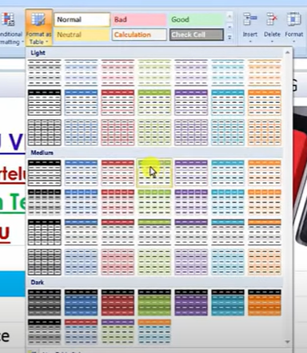

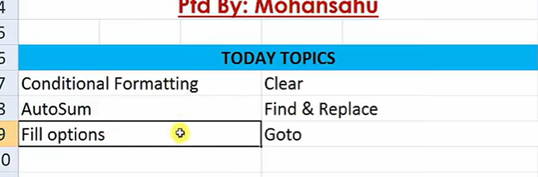

**Conditional formatting:**

**Colors to highest and lowest**

**Home : conditional formatting**

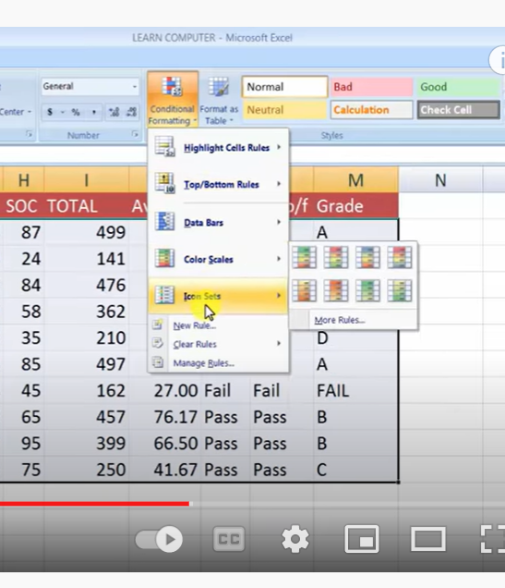

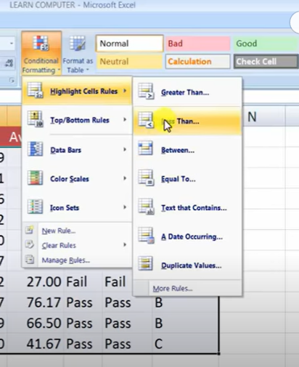

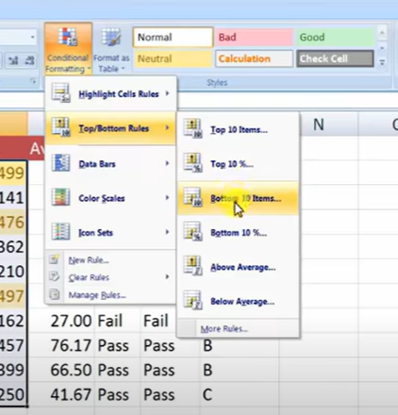

**Clear rules also there**

**New rule**

**Auto sum:**

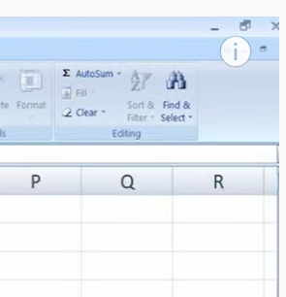

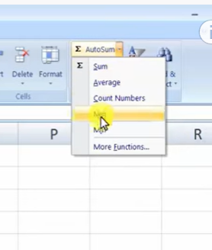

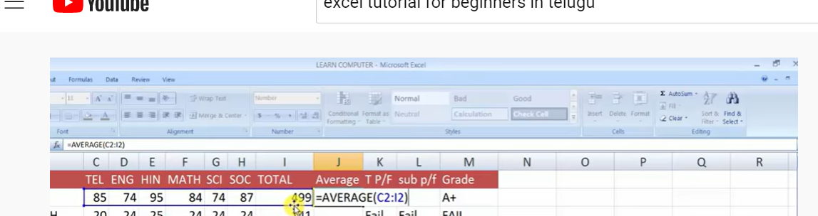

**Filling:**

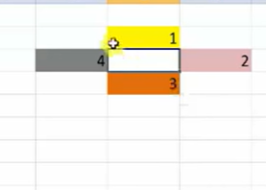

**Filling top or down or right or left**

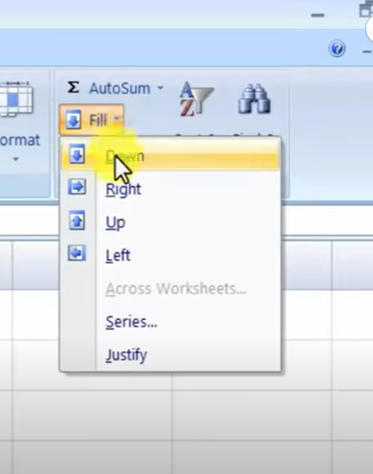

**Even formula will be shifted**

**Select where to apply and use control d**

**Or Control D**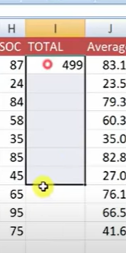

**Clear :**

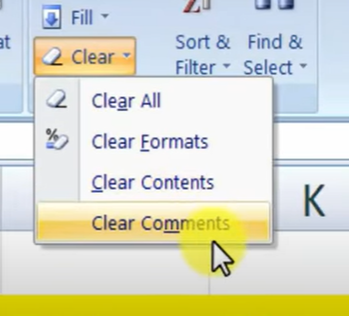

**First select data**

**FIND and REPLACE**

**To find data – find**

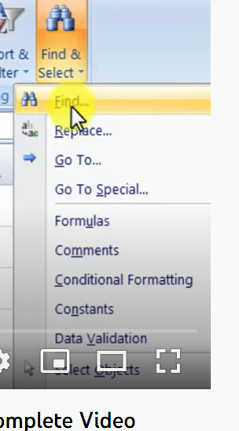

**Click on find or control F**

**RePlace:**

**Rajesh should be replace by Rajasekar**

**Click on find and replace**

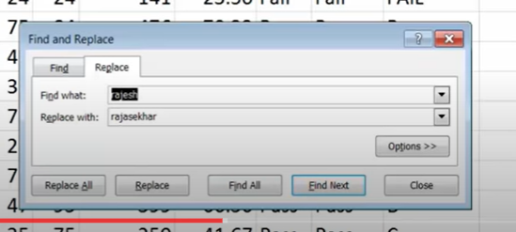

**GOTO**

**Goto special**

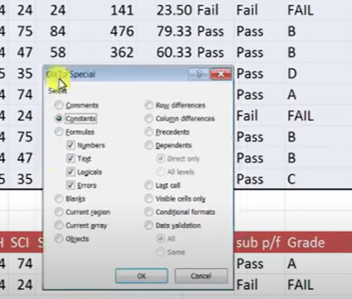

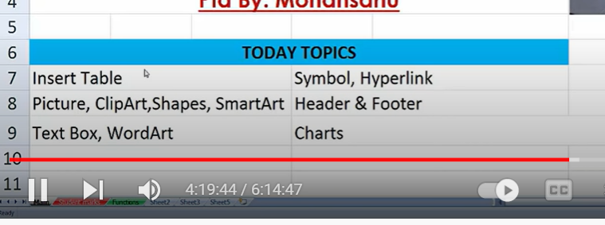

**Insert tab**

**To convert data into table format**

**Select content**

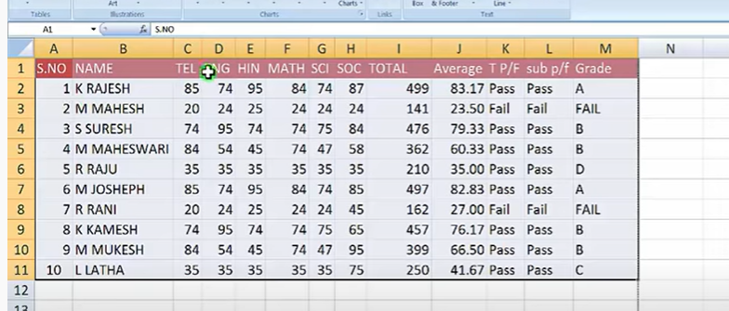

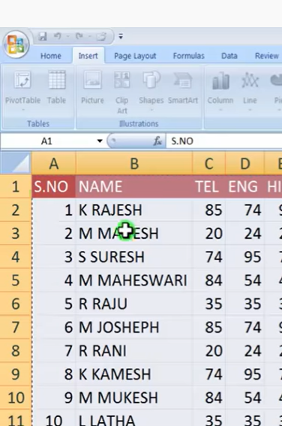

**Select table**

**And criteria range**

**INSERT PICTURES AND CLIP ART**

**CLIP art**

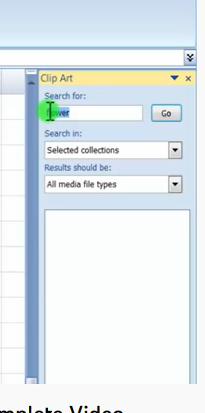

**Drawing pics**

**Text box in insert tab**

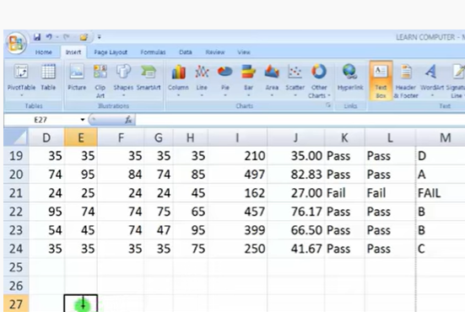

**Symbol**

**Insert symbol**

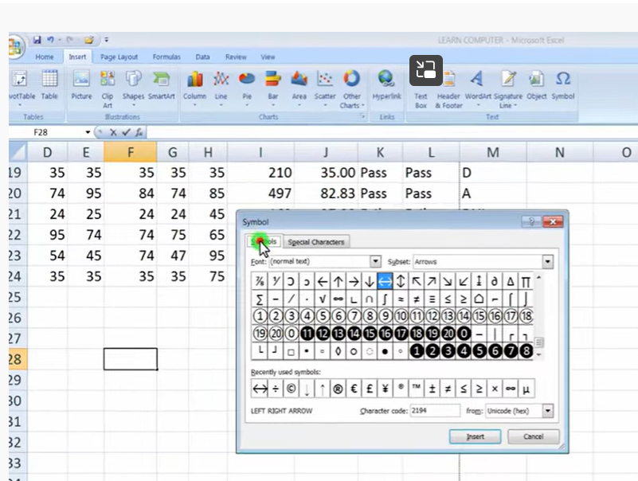

**Hyperlink : to merge file in another place**

**Select cell- insert -hyperlink**

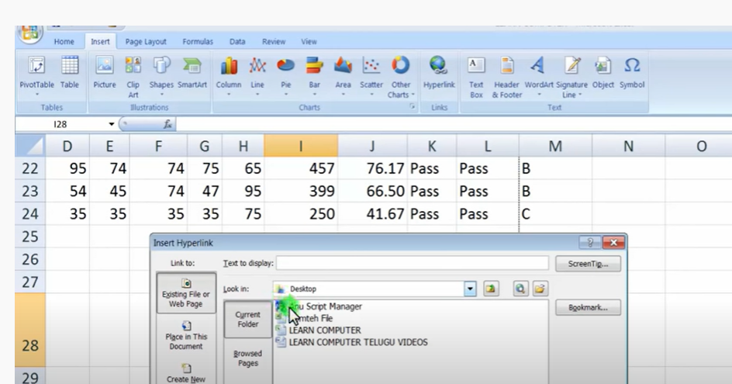

**INSERT-Chart**

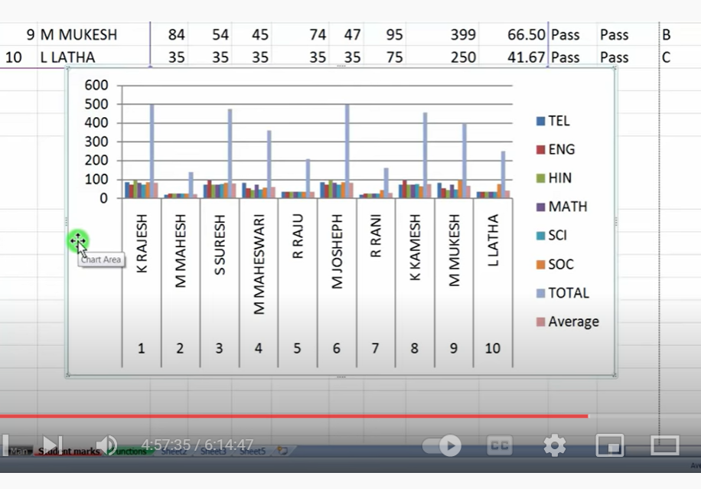

**Total chart area – plot area**

**Bars: series**

**Horizontal lines: Grid lines**

**X axis**

**Y**

**Legend area**

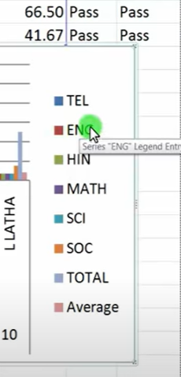

**To change data range:**

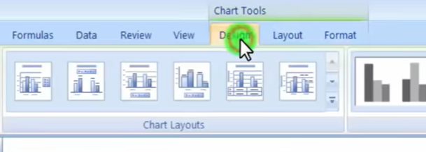

**Design- select data-legend entries to select columns**

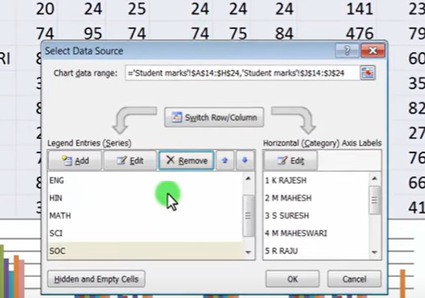

**To change link this**

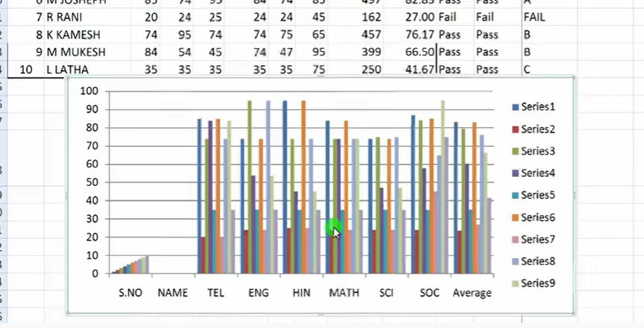

**Chart tools - design- switch row/column**

**Data tab**

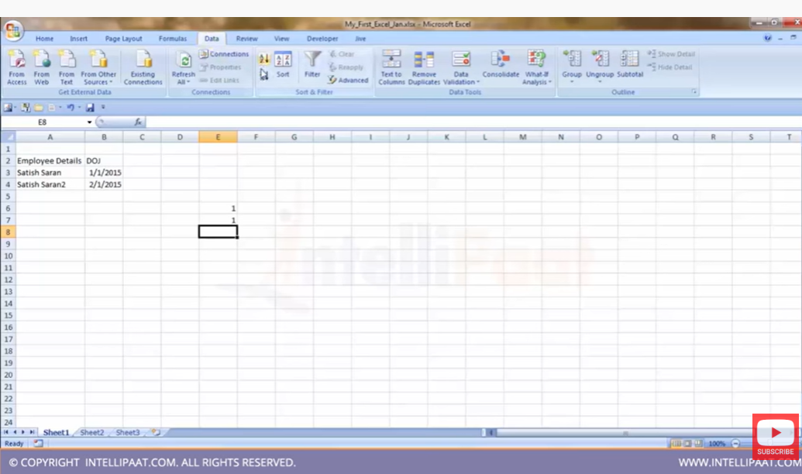

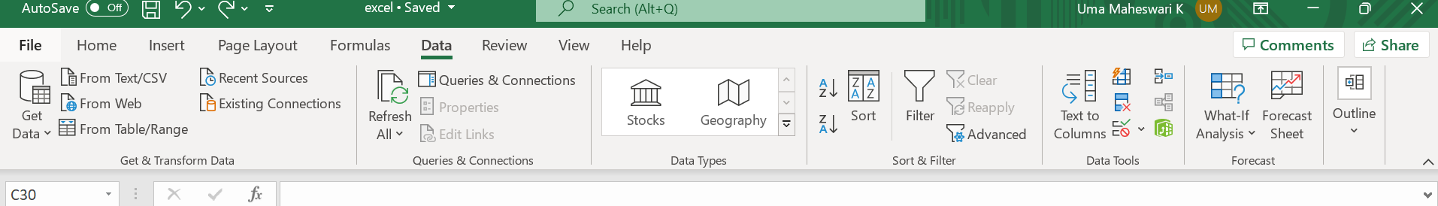

**To go to last and first cell where data available:**

**Control + right arrow**

**To select row of full data : ctr+shift +right arrow**

**To select entire column: contro+shift +down arrow**

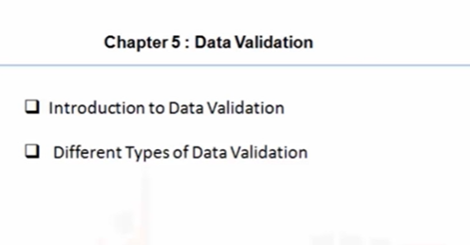

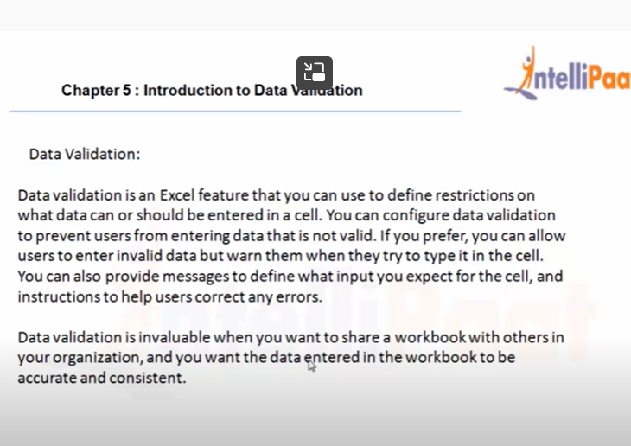

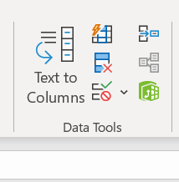

**To set a specific data type for a column**

**Select cell- data validation – type of data**

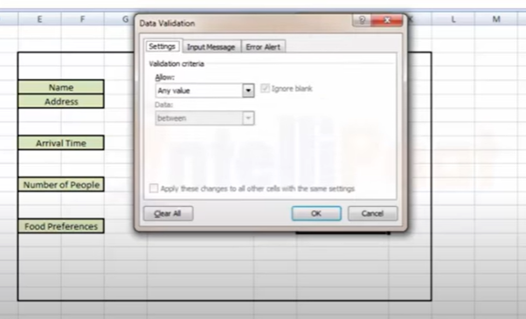

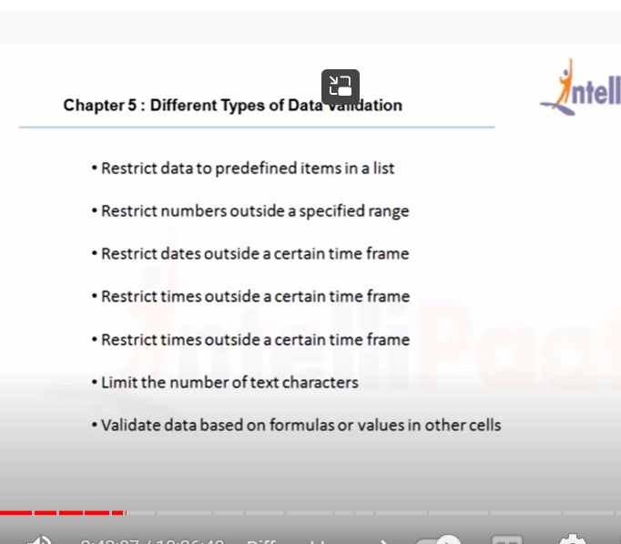

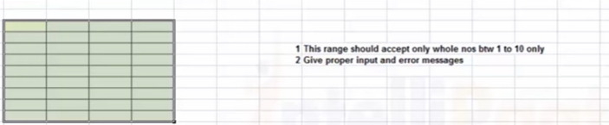

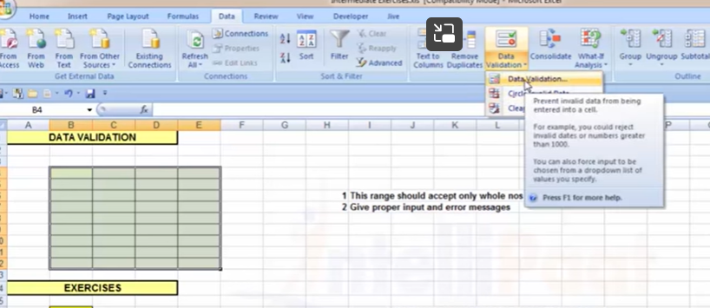

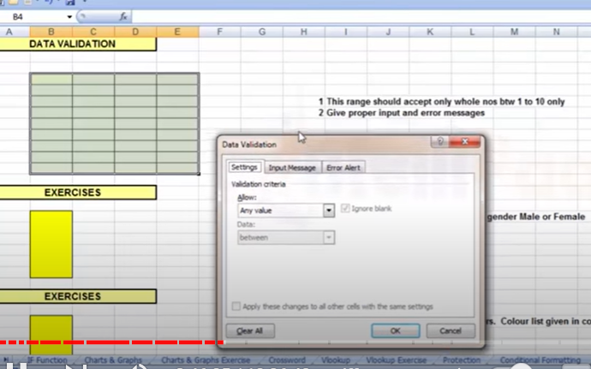

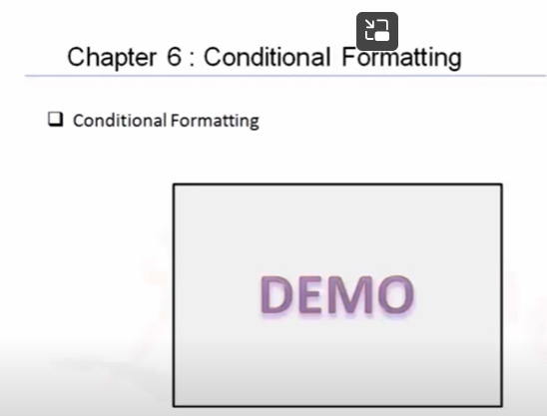

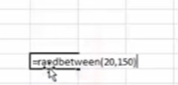

**Filterdata**

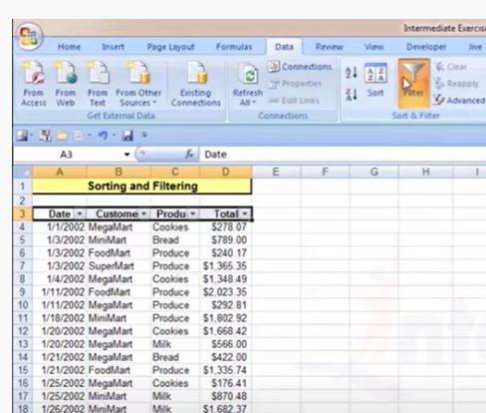

**Again click on filter to come to original level**

**Custom sort**

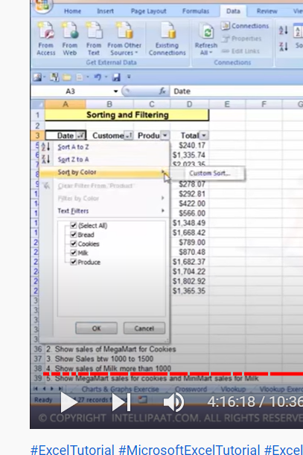

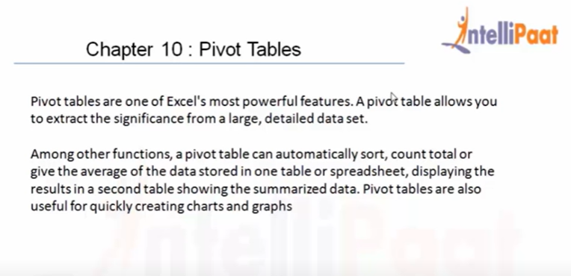

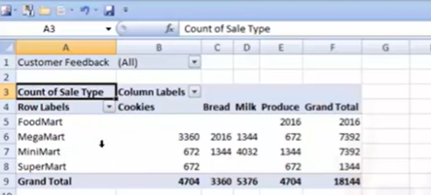

**Row label**

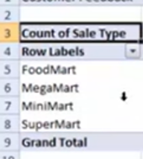

**Column**

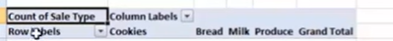

**Values**

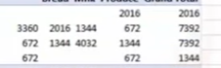

**Pivot table summarize**

**No data should be empty**

**Pivot table fields**

**4 partitions**

**1 filters**

**2. columns**

**3. row**

**4. values(only number fields)**

**Pivot table is flexible and summarize**

**To know the information about each cell how we got: double click cell**

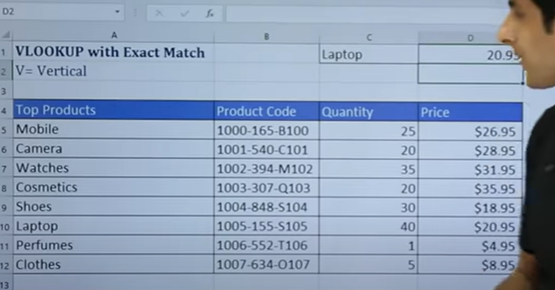

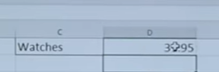

**To find above is easy**

**Look up value in table**

**=VLOOKUP**

**(lookup value,select table, which column number,0 or 1)**

**Table should be selected without column names**

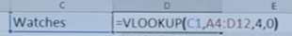

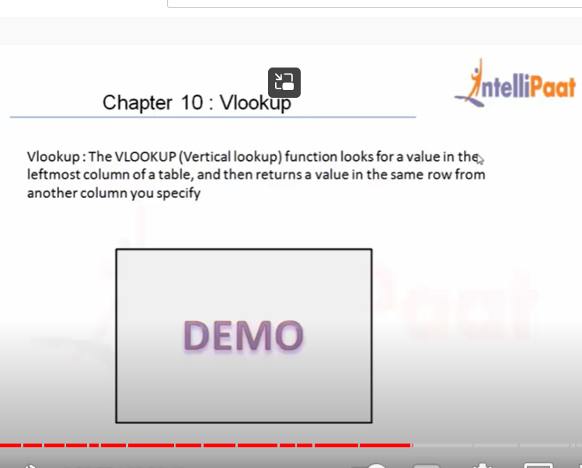

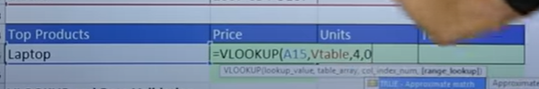

**Instead of typing product – drop down**

**Data tab- Data Validation – list**

**MS Excel - VLookup Approximate Match**

**0 and 1**

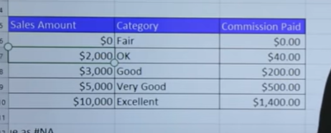

**People may not to exact 5000 dollar sales**

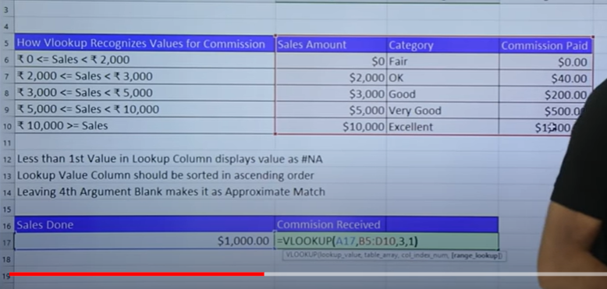

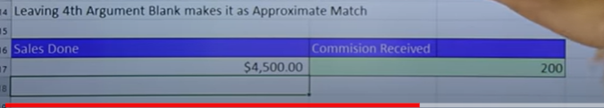

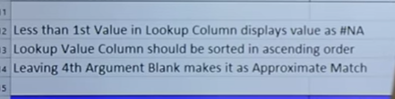

**VLookup with Trim**

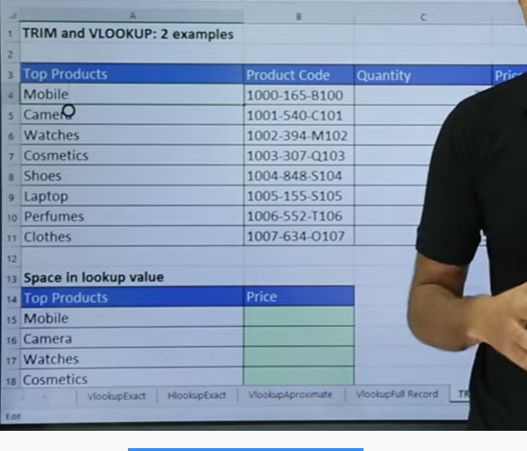

**Trim will remove unwanted spaces**

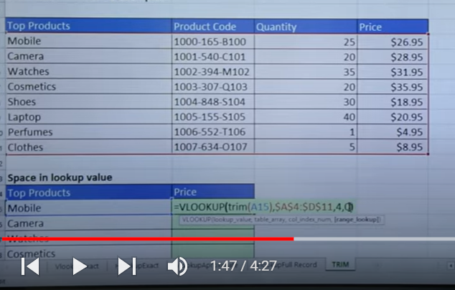

**Drag**

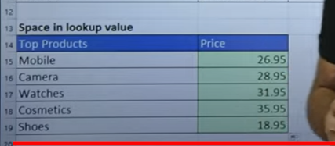

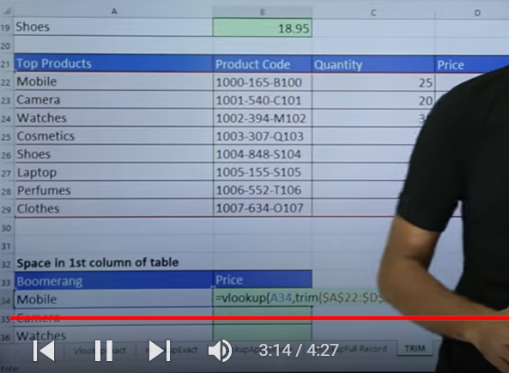

**When u wanted to trim entire table**

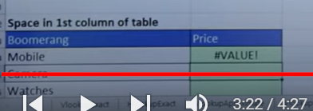

**When we are using array function : control shift enter – to get answer**

**Left hand text**

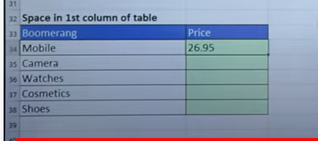

**Numbers – right hand**

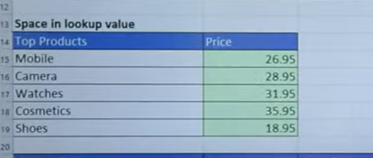

**To convert to number**

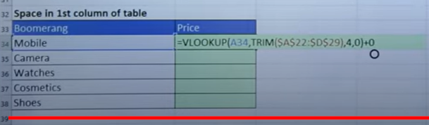

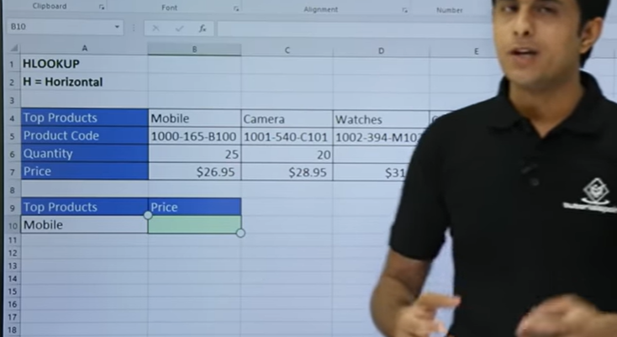

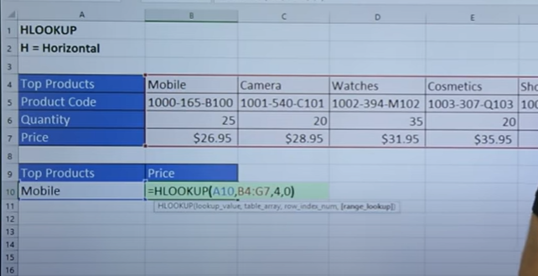

**Horizontal: row index number**

**VLookup Rules**



**Mobile repeated n number of times, but look up value should be unique in the table**

**Look up can be possible from left to right**

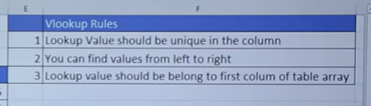

**Lookup Function**

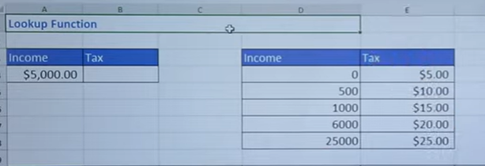

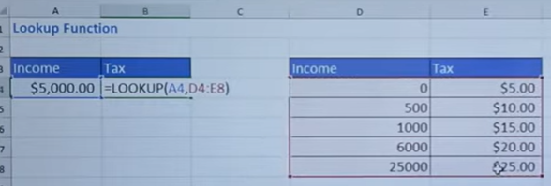

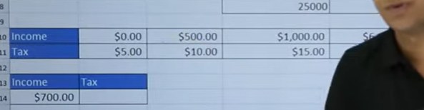

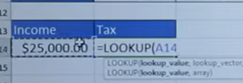

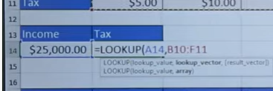

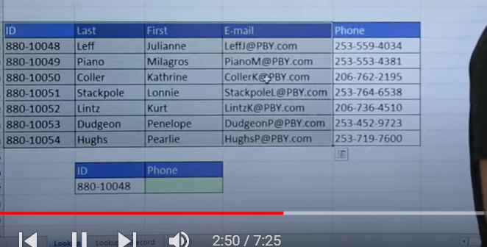

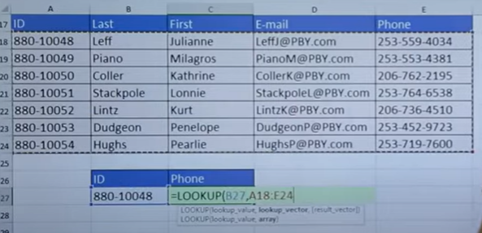

**When I want third column**

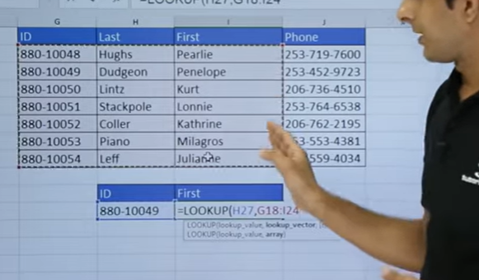

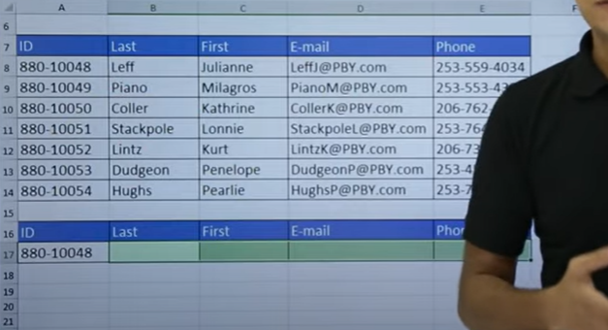

**Look up : value, look up vector, result vector**

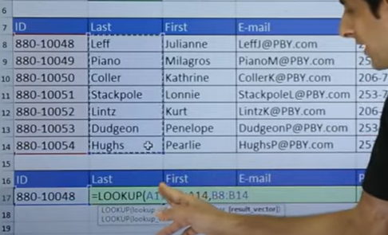

**Value and look up vector fixed**

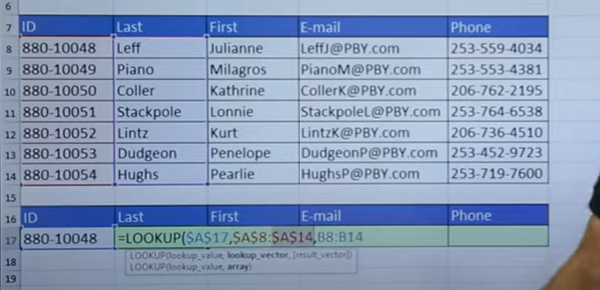

**To get dollar symbol: F4**

**Drag right hand side**

**Lookup Full Record**

